

CHANDIGARH GROUP OF COLLEGES

LANDRAN

**PROJECT REPORT ON DEMO ON ONLINE MOVIE BOOKING USING C LANGUAGE**

SUBMITTED BY : MANAS RAJ

ROLL NO. : 2121357

SECTION : C1 SEMESTER : 3rd COURSE :B.TECH BRANCH : CSE

SUBMITTED TO :Mr. UPINDERPAL SINGH

*INDEX*

|  |  |
| --- | --- |
| *TITLE* | *PAGE NO.* |
| Abstract | 03 |
| Introduction to c | 04 |
| ABOUT | 05 |
| Programming explanation | 06-08 |
| Source code | 09-14 |
| Snapshots | 14 |
| Conclusion | 15 |

**ABSTRACT**

Simple Movie Ticket Booking System is based on the concept of booking movie tickets. There’s no login system available for this system, the user can freely use its feature. This mini project contains limited features, but the essential one.

Talking about the features of this Simple system, the user can book movie tickets. For this, the user has to select a movie name, enter customer details such as name and phone number. Then the user has to enter seat number. After this, the booking is done. The user can also change the ticket price and view reservations by entering the admin password. The last feature of this project is about canceling the tickets which can be done by entering the booking id. This **Movie Ticket Booking System Project in C** concept of the Simple Movie Ticket Booking System is to book movie tickets. This system does not have a login system, thus the user is free to use its features. This little project has only a few features, but they are all necessary. The user can book cinema tickets using the capabilities of this Simple system. To do so, the user must first choose a movie title and then submit customer information such as name and phone number. The user must then enter the seat number. After then, the reservation is complete. By inputting the admin password, the user can also adjust the ticket price and view reservations. The final element of this project is the ability to cancel tickets by entering the booking id. The system does not create an external file to permanently save the user’s data. This system was written in the C programming language, and several variables and strings were employed in its creation.

INTRODUCTION TO C PROGRAMMING

**C programming** is a general-purpose, procedural, imperative computer programming language developed in 1972 by Dennis M. Ritchie at the Bell Telephone Laboratories to develop the UNIX operating system. C is the most widely used computer language. It keeps fluctuating at number one scale of popularity along with Java programming language, which is also equally popular and most widely used among modern software programmers.

**Why to Learn C Programming?**

**C programming** language is a must for students and working professionals to become a great Software Engineer specially when they are working in Software Development Domain. I will list down some of the key advantages of learning C Programming:

* Easy to learn
* Structured language
* It produces efficient programs
* It can handle low-level activities
* It can be compiled on a variety of computer platforms

**Compiler:** A compiler is a software program that compiles program source code files into an executable program. It included as part of integrated development environment IDE with most programming software packages.

**ABOUT**

Thisproject provide the customers facility to movies tickets booking and also view all the movies playing in cinema hall ,through which they can book ticket anytime, anywhere .Movie ticket booking system is basically made for Providing the customer at anytime and anywhere service for booking the seat in the cinema hall and information about the movies . The user can be easily able to know about the movies released and then make the choice .In this project, we will illustrate our system by providing C language .This project uses the concept of File Handling. Admin can check all the transaction It allows users to access their booking history . It allows booking of the ticket at any time without having any maintenance slots.

PROBLEM STATEMENT:

To create a platform for public to book tickets for movie of any application and by using internet

Objectives:

i. To provide another way for the customer to buy cinema ticket, get the information about        movies.

ii. To provide the customer the complete information of the movie, according to which the        customer can view all the movies, book the tickets and the view all transactions facility         provides more flexibility to the system.

**FLOWCHARTS**

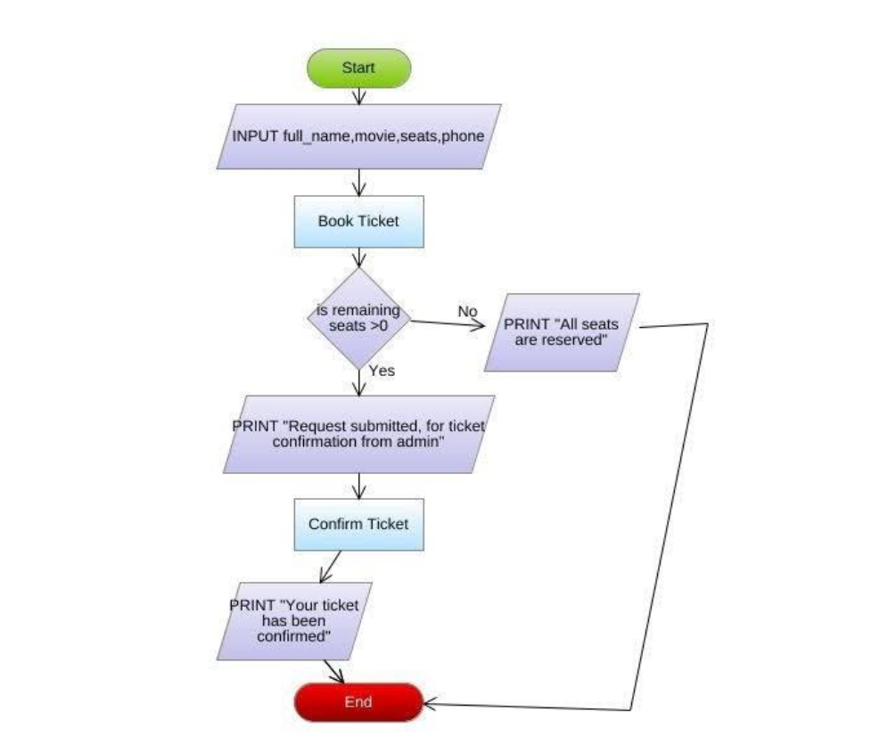

# Programming:

In this section we will describe the program in programming aspect. Like what is the technique working behind the program? And how the program actually work?

# Header File

In this program we have included only one header file that is stdio.h

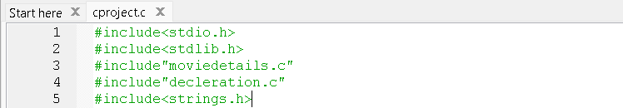

Stdio.h file is the name of the standard library definition file for all Standard Input ,Output.

# Main Body of Program:

The next part of a C program is to the main() function . The syntax to declaration the main function is:

Syntax to declare the main function:

int main()

{

}

**Body:** The body of a function in the C program , refers to the operations that are performed in the functions. It can be anything like manipulations,searching,sorting,printing ,etc.

***Variable Declaration:*** The next part of any C program is the variable declaration .it refers to the variables that are to be used in the function.Please note that in the C program, no variable can be used without being declared.Also in a C program,the variables are to be declared before any operation in the function.

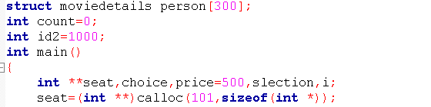

**Goto statement:** The goto statement is a jump statement which is sometimes also referred to as unconditional jump statement. The goto statement can be used to jump from anywhere to anywhere within a function.

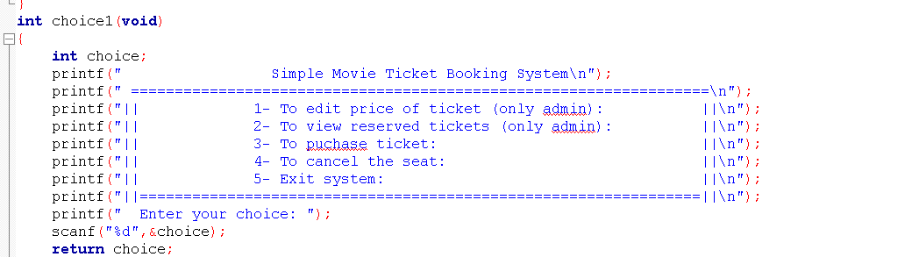

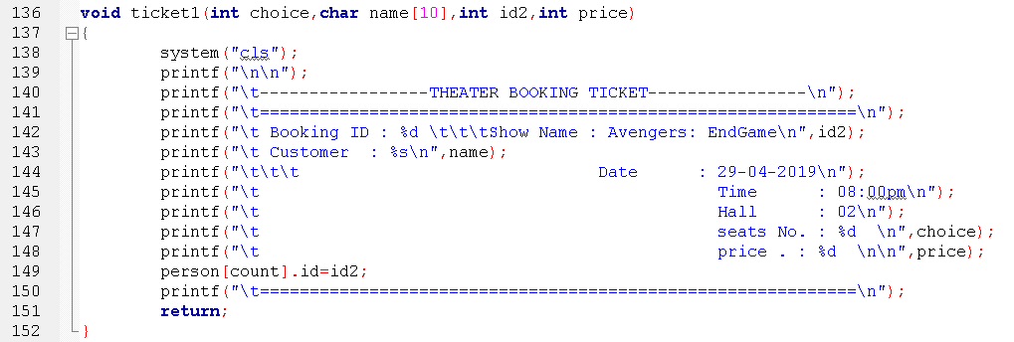 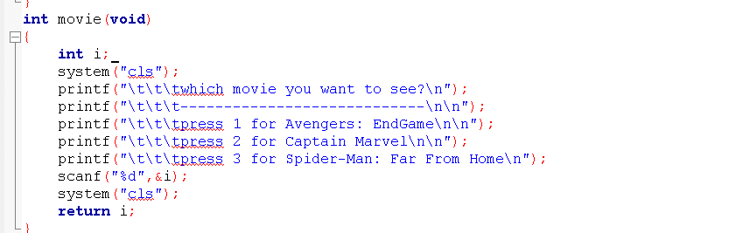

**If - else-if statement :**The if-else-if ladder statement is an extension to the if else statement. It is used in the scenario where there are multiple cases to be performed for different conditions. In if-else-if ladder statement, if a condition is true then the statements defined in the if block will be executed, otherwise if some other condition is true then the statements defined in the else-if block will be executed, at the last if none of the condition is true then the statements defined in the else block will be executed. There are multiple else-if blocks possible. It is similar to the switch case statement where the default is executed instead of else block if none of the cases is matched.

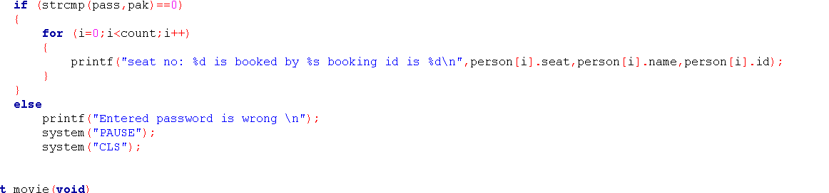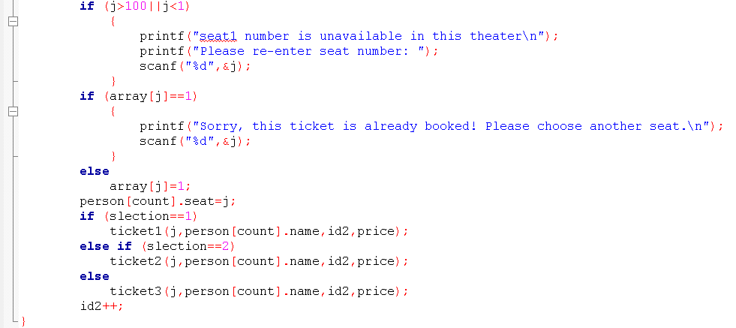

**Source code**

**#include<stdio.h>**

**#include<stdlib.h>**

**#include"moviedetails.c"**

**#include"decleration.c"**

**#include<strings.h>**

**struct moviedetails person[300];**

**int count=0;**

**int id2=1000;**

**int main()**

**{**

**int **seat,choice,price=500,slection,i;**

**seat=(int **)calloc(101,sizeof(int *));**

**for (i=0;i<3;i++)**

**\*(seat+i)=(int *)calloc(101,sizeof(int ));**

**int x;**

**while(x!=5)**

**{**

**choice=choice1();**

**switch(choice)**

**{**

**case 1:**

**price=changeprize(price);**

**break;**

**case 2:**

**details();**

**break;**

**case 3:**

**slection=movie();**

**reservation(seat[slection-1],price,slection);**

**count++;**

**break;**

**case 4:**

**slection=cmovie();**

**cancel(seat[slection-1]);**

**break;**

**case 5:**

**x=5;**

**break;**

**default:**

**printf("Choice not available\n");**

**break;**

**}**

**}**

**}**

**int changeprize(int prize)**

**{**

**char pass[10],pak[10]="pass";**

**printf("Enter the password to change price of ticket: ");**

**scanf("%s",&pass);**

**if (strcmp(pass,pak)==0)**

**{**

**printf("Please enter new price: ");**

**scanf("%d",&prize);**

**system("PAUSE");**

**system("CLS");**

**}**

**else**

**printf("The entered password is wrong! ");**

**return prize;**

**}**

**void reservation(int *array,int price,int slection)**

**{**

**int i,j;**

**printf("\n SCREEN\n\n\n");**

**for (i=1;i<=100;i++)**

**{**

**if (array[i]==0)**

**printf("%d\t",i);**

**else**

**printf("*\t",i);**

**if(i%10==0)**

**printf("\n\n");**

**}**

**printf("Please enter your name: ");**

**scanf(" %19[^\n]%*[^\n]",&person[count].name);**

**printf("Please enter your phone number: ");**

**scanf("%u",&person[count].phone);**

**printf("Which seat number you want? ");**

**scanf("%d",&j);**

**if (j>100||j<1)**

**{**

**printf("seat1 number is unavailable in this theater\n");**

**printf("Please re-enter seat number: ");**

**scanf("%d",&j);**

**}**

**if (array[j]==1)**

**{**

**printf("Sorry, this ticket is already booked! Please choose another seat.\n");**

**scanf("%d",&j);**

**}**

**else**

**array[j]=1;**

**person[count].seat=j;**

**if (slection==1)**

**ticket1(j,person[count].name,id2,price);**

**else if (slection==2)**

**ticket2(j,person[count].name,id2,price);**

**else**

**ticket3(j,person[count].name,id2,price);**

**id2++;**

**}**

**int choice1(void)**

**{**

**int choice;**

**printf(" Simple Movie Ticket Booking System\n");**

**printf(" ==================================================================\n");**

**printf("|| 1- To edit price of ticket (only admin): ||\n");**

**printf("|| 2- To view reserved tickets (only admin): ||\n");**

**printf("|| 3- To puchase ticket: ||\n");**

**printf("|| 4- To cancel the seat: ||\n");**

**printf("|| 5- Exit system: ||\n");**

**printf("||================================================================||\n");**

**printf(" Enter your choice: ");**

**scanf("%d",&choice);**

**return choice;**

**}**

**void cancel(int *array)**

**{**

**int Cseat,i,stop;**

**printf("Please enter ID number of ticket: ");**

**scanf("%d",&Cseat);**

**for (i=0;i<300;i++)**

**{**

**if(Cseat==person[i].id)**

**{**

**stop=5;**

**system("cls");**

**printf("%s your seat is %d cancelled",person[i].name,person[i].seat);**

**array[person[i].seat]=0;**

**i=300;**

**}**

**}**

**if (stop!=5)**

**printf("Ticket ID number is incorrect please enter right one to cancel ticket: \n");**

**}**

**void ticket1(int choice,char name[10],int id2,int price)**

**{**

**system("cls");**

**printf("\n\n");**

**printf("\t-----------------THEATER BOOKING TICKET----------------\n");**

**printf("\t============================================================\n");**

**printf("\t Booking ID : %d \t\t\tShow Name : Avengers: EndGame\n",id2);**

**printf("\t Customer : %s\n",name);**

**printf("\t\t\t Date : 29-04-2019\n");**

**printf("\t Time : 08:00pm\n");**

**printf("\t Hall : 02\n");**

**printf("\t seats No. : %d \n",choice);**

**printf("\t price . : %d \n\n",price);**

**person[count].id=id2;**

**printf("\t============================================================\n");**

**return;**

**}**

**void details(void)**

**{**

**int i;**

**char pass[10],pak[10]="pass";**

**printf("Enter the password to see details: ");**

**scanf("%s",&pass);**

**if (strcmp(pass,pak)==0){**

**for (i=0;i<count;i++){**

**printf("seat no: %d is booked by %s booking id is %d\n,person[i].seat,person[i].name,person[i].id);**

**}**

**else**

**printf("Entered password is wrong \n");**

**system("PAUSE");**

**system("CLS");**

**}**

**int movie(void){**

**int i;**

**system("cls");**

**printf("\t\t\twhich movie you want to see?\n");**

**printf("\t\t\t----------------------------\n\n");**

**printf("\t\t\tpress 1 for Avengers: EndGame\n\n");**

**printf("\t\t\tpress 2 for Captain Marvel\n\n");**

**printf("\t\t\tpress 3 for Spider-Man: Far From Home\n");**

**scanf("%d",&i);**

**system("cls");**

**return i;**

**}**

**void ticket2(int choice,char name[10],int id2,int price){**

**system("cls");**

**printf("\n\n");**

**printf("\t-----------------THEATER BOOKING TICKET----------------\n");**

**printf("\t============================================================\n");**

**printf("\t Booking ID : %d \t\t\tShow Name : Captain Marvel\n",id2);**

**printf("\t Customer : %s\n",name);**

**printf("\t\t\t Date : 15-04-2019\n");**

**printf("\t Time : 09:00pm\n");**

**printf("\t Hall : 03\n");**

**printf("\t seats No. : %d \n",choice);**

**printf("\t price . : %d \n\n",price);**

**person[count].id=id2;**

**printf("\t============================================================\n");**

**return;**

**}**

**int cmovie(void){**

**int i;**

**printf("\t\t\twhich movie ticket you want to cancel\n");**

**printf("\t\t\t-------------------------------------\n");**

**printf("\t\t\tpress 1 for Avengers: EndGame\n\n");**

**printf("\t\t\tpress 2 for Captain Marvel\n\n");**

**printf("\t\t\tpress 3 for Spider-Man: Far From Home\n");**

**scanf("%d",&i);**

**return i;**

**}**

**void ticket3(int choice,char name[10],int id2,int price){**

**system("cls");**

**printf("\n\n");**

**printf("\t-----------------THEATER BOOKING TICKET----------------\n");**

**printf("\t============================================================\n");**

**printf("\t Booking ID : %d \t\t\tShow Name : Spider-Man: Far From Home \n",id2);**

**printf("\t Customer : %s\n",name);**

**printf("\t\t\t Date : 5-07-2019\n");**

**printf("\t Time : 10:00pm\n");**

**printf("\t Hall : 04\n");**

**printf("\t seats No. : %d \n",choice);**

**printf("\t price . : %d \n\n",price);**

**person[count].id=id2;**

**printf("\t============================================================\n");**

**return;**

**}**

**Screenshots**

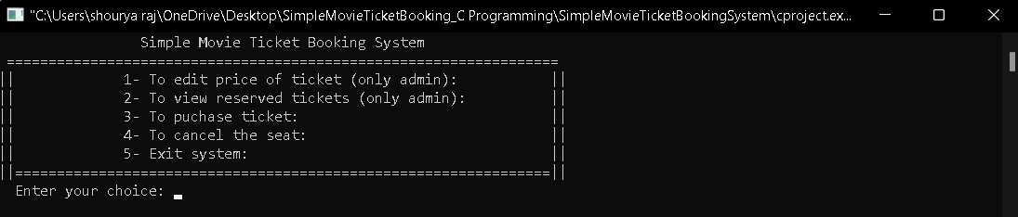 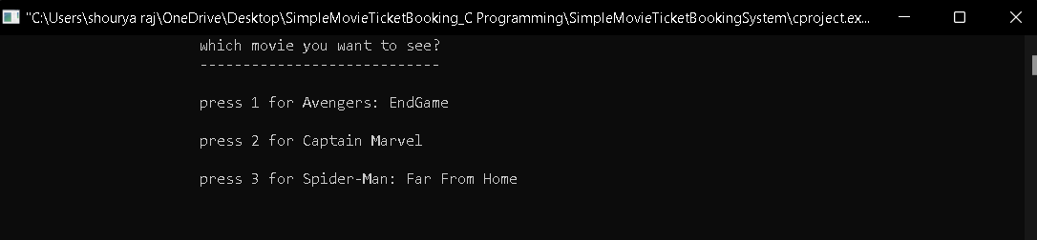 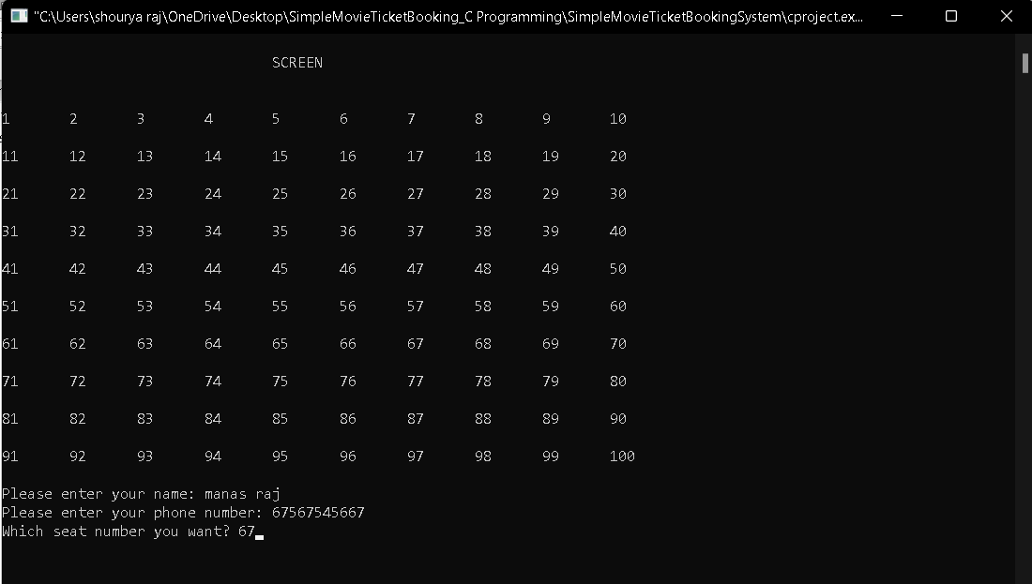 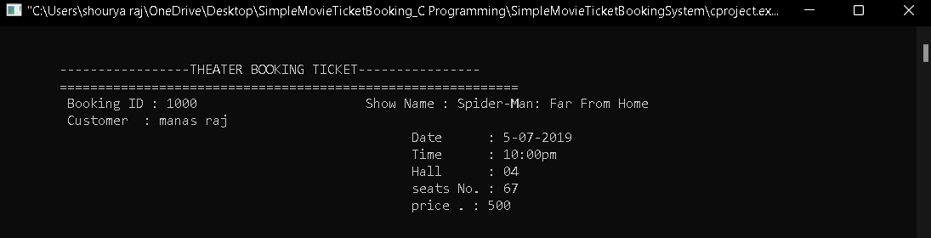

*Conclusion*

This demo of online movie booking system is basic example of C language in which we used various basic header files, datatypes , statements and arithmetic operators to get the apporopriate output. The user is prompted to choose the movie they like and to enjoy. Customers can book movie tickets and view all of the movies playing in the cinema hall through this project, which allows them to book tickets at any time and from anywhere. The movie ticket reservation system was created with this in mind. Providing customers with service to book a seat in the cinema hall and information about the films at any time and from any location. The consumer may simply learn about the movies that have been released and then make a decision. We will demonstrate our system in this project by using the C programming language. The notion of File Handling is used in this project. All transactions can be viewed by the administrator. It allows users to see their previous bookings. It allows you to book a ticket at any moment without having to wait for maintenance.